**Report view**: A Power BI report is a multi-perspective view into a dataset, with visuals that represent different findings and insights from that dataset. A report can have a single visual or pages full of visuals. ... You also may be someone who consumes or uses reports.

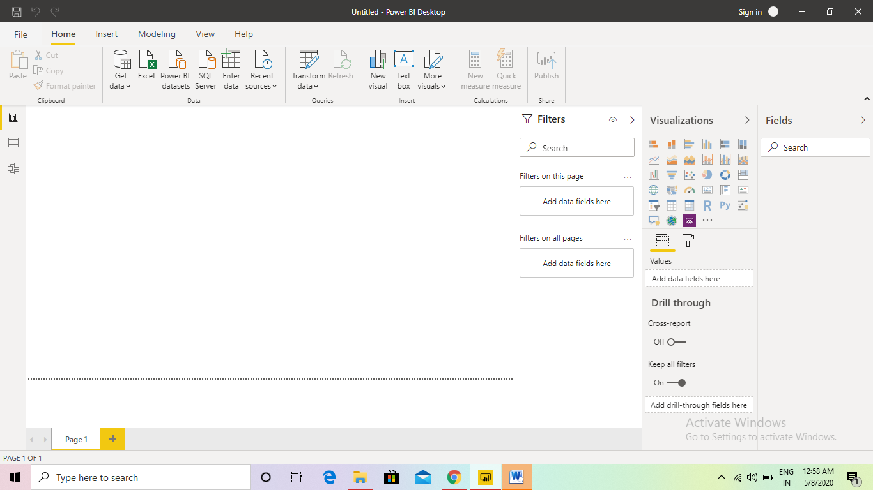

**Data view**: Data view helps you inspect, explore, and understand data in your Power BI Desktop model. It's different from how you view tables, columns, and data in Power Query Editor. With Data view, you're looking at your data after it has been loaded into the model. Note.

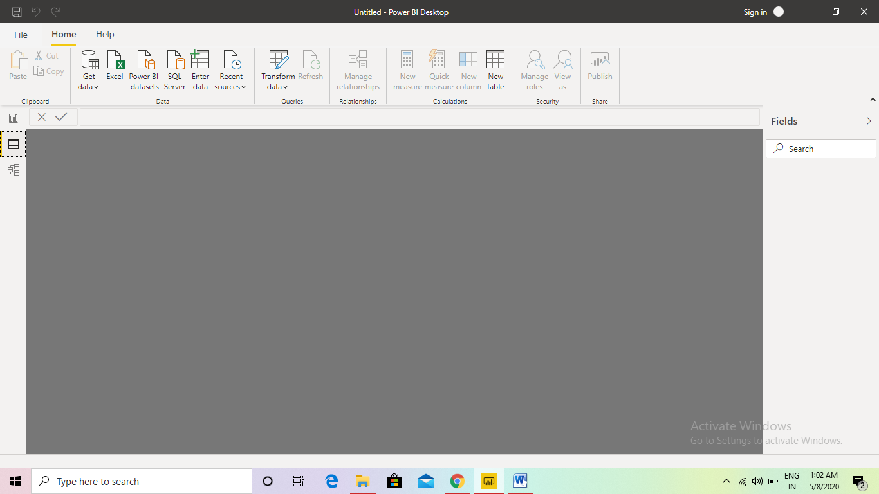

**Model view**: Model view shows all of the tables, columns, and relationships in your model. This view can be especially helpful when your model has complex relationships between many tables. Select the Model icon near the side of the window to see a view of the existing model.

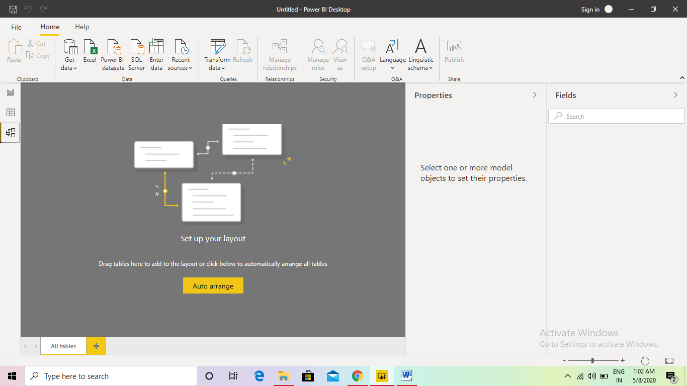

**Power Query editor:** The Query Editor in Power BI is used to transform or edit data files before they are actually loaded into the Power BI. The Query Editor plays the role of an intermediate data container where you can modify data by selecting rows and columns, splitting rows and columns, pivoting and columns, etc.

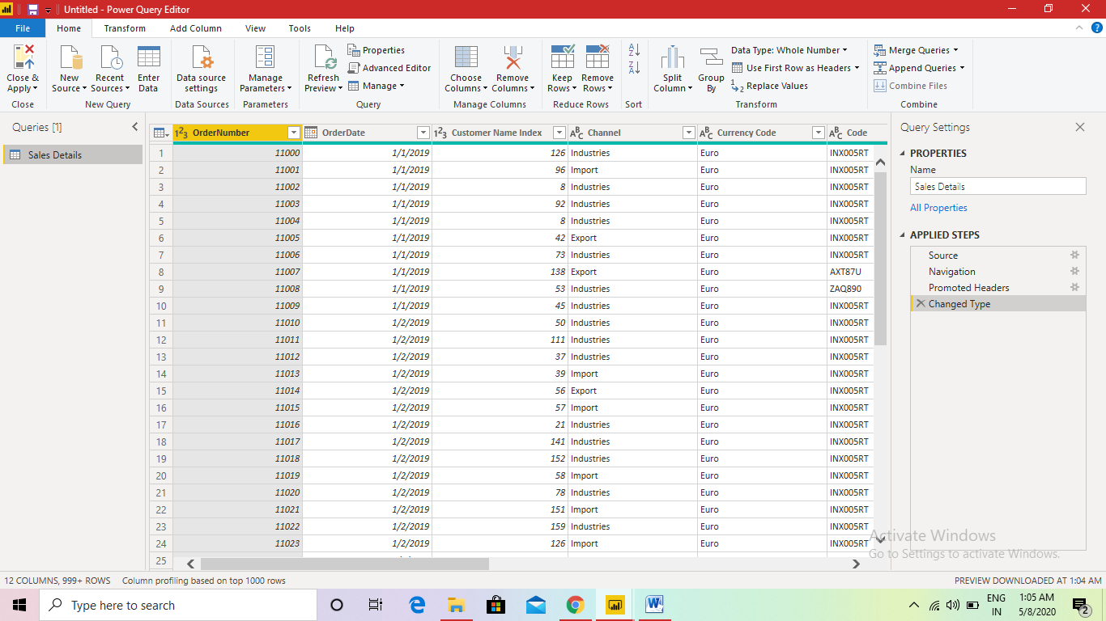

**Advanced editor:** The Advanced Editor lets you see the code that Power Query Editor is creating with each step. It also lets you create your own shaping code. To launch the advanced editor, select View from the ribbon, then select Advanced Editor. A window appears, showing the existing query code.

